2 ideas:
existing data.
Additional Data — User Assistance & Warnings
- Relief Camps & Shelters: Locations, capacity, facilities, and availability.
- Safe Routes & Evacuation Points
- User Location-Based Alerts
- Nearby Disaster Warnings
- Emergency Contacts & Helplines
- Help Requests & Assistance Needs

1. Overview
- Current situation summary (active events, key risks), each labeled by epistemic status
- Compact map of active events
- Latest updates feed
- Data freshness indicator per source

2. Map Explorer
- Layers: modality events, unified events, rainfall/weather, administrative boundaries, landslide inventory
- Filters: hazard, time range, severity, status, region
- Click-through to an event card
- Legend that separates observed, official, reported, AI-inferred, and predicted

3. Events
- Filterable list or table (hazard, region, time, severity, verification status)
- Event detail page:
  - Headline attributes with source and confidence
  - Timeline
  - Supporting and contradicting evidence
  - Contributing modality events
  - Affected regions
  - Impacts, labeled observed vs. predicted
  - Related events

4. Modality Events
- List of events detected within individual modalities, such as earthquake, weather, news, and social media
- Filters: modality, hazard, region, time range, and processing status
- Event details: detection source, event time, location, and available confidence
- Supporting observations and derived results
- Link to the corresponding unified event, if matched
- Clear distinction between detected events, reported incidents, AI inferences, and predictions

5. Event Groups (Episodes)
- Episode list and detail
- Relationship graph or timeline (e.g., rainfall → landslide → road blockage)
- Each link labeled: confirmed, reported, inferred, or possible
- Combined impact and affected area

6. Reports and Evidence
- Source-backed feed: official reports, news, social/multimedia
- Filters: source type, verification status, hazard, region
- Link to the original source
- Language/translation toggle
- Clearly marked unverified items

7. History and Trends
- Historical event search
- Seasonal and regional patterns
- Landslide inventory exploration
- Comparison with past events

8. Preparedness and Response
- Verified emergency contacts, shelters, relief resources, safety guidance
- "Last verified" date on every item
- No routes or resources shown as safe or available unless confirmed

9. Ask (Evidence-Grounded Q&A)
- Natural-language search over events and reports
- Answers with citations to evidence
- Statements marked as fact, inference, or prediction

10. My Area / Settings
- Saved regions and hazards (watchlist)
- Notification preferences
- Units, language, and map defaults

1. Overview
- Current situation summary (active events, active official warnings, top risks), each labeled by epistemic status
- Compact map of active events
- Latest updates feed
- Data freshness indicator per source

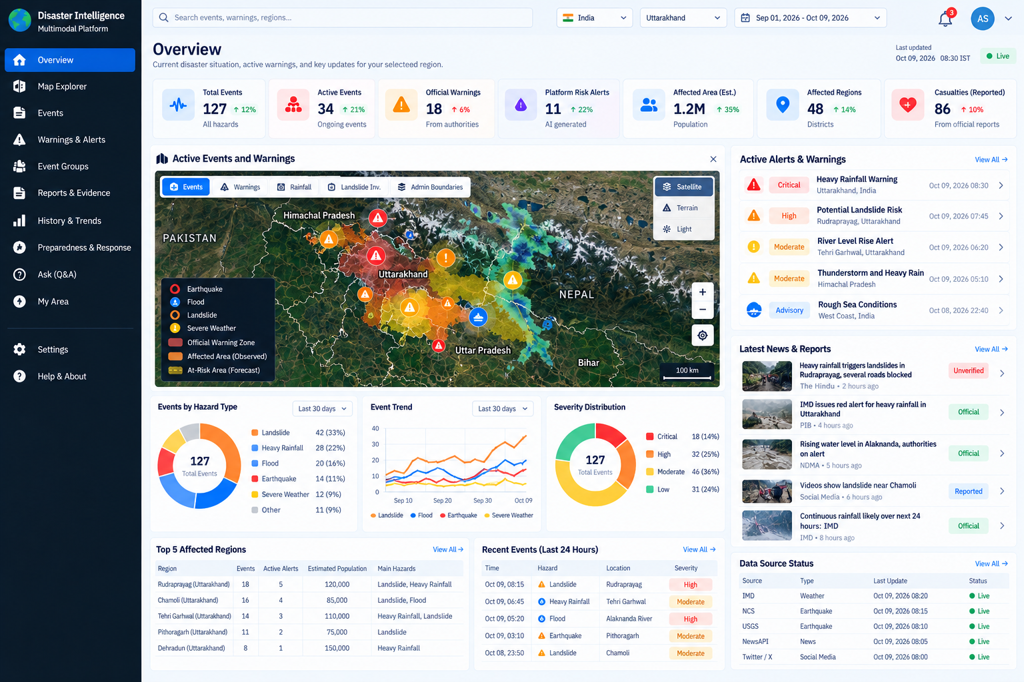

2. Map Explorer
- Layers: events, official warnings, rainfall/weather, admin boundaries, landslide inventory
- Filters: hazard, time range, severity, status, region
- Click-through to an event card
- Legend that separates observed, official, reported, and predicted
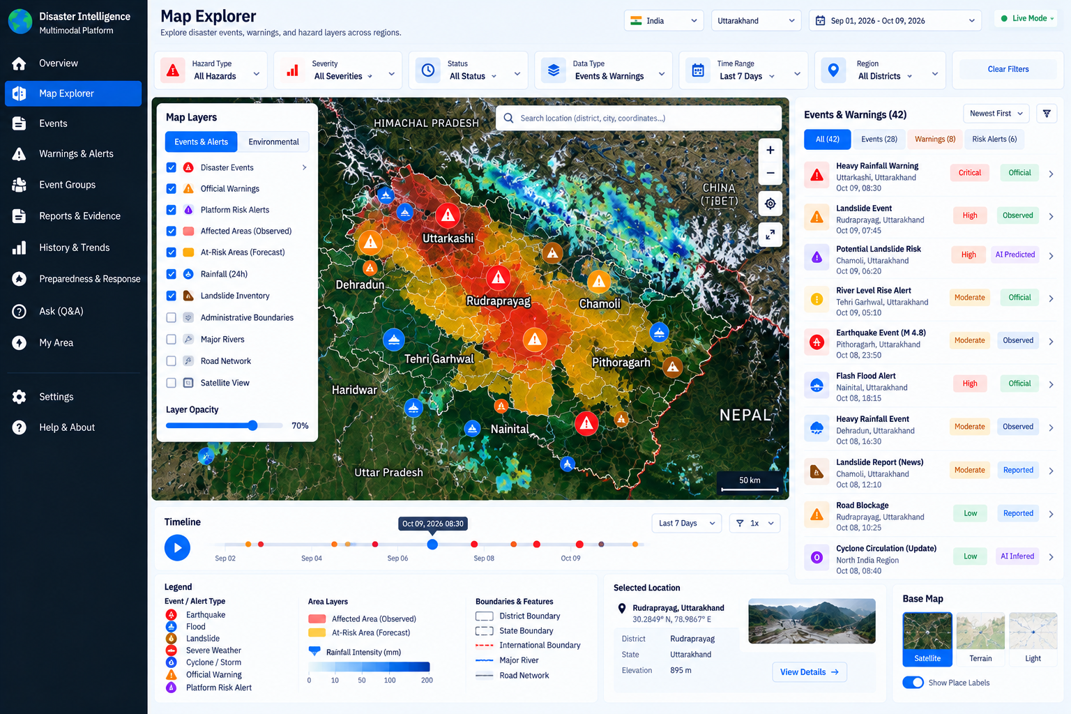
3. Events
- Filterable list or table (hazard, region, time, severity, verification status)
- Event detail page:
  - Headline attributes with source and confidence
  - Timeline
  - Supporting and contradicting evidence
  - Contributing modality events
  - Affected regions
  - Impacts, labeled observed vs. predicted
  - Related events
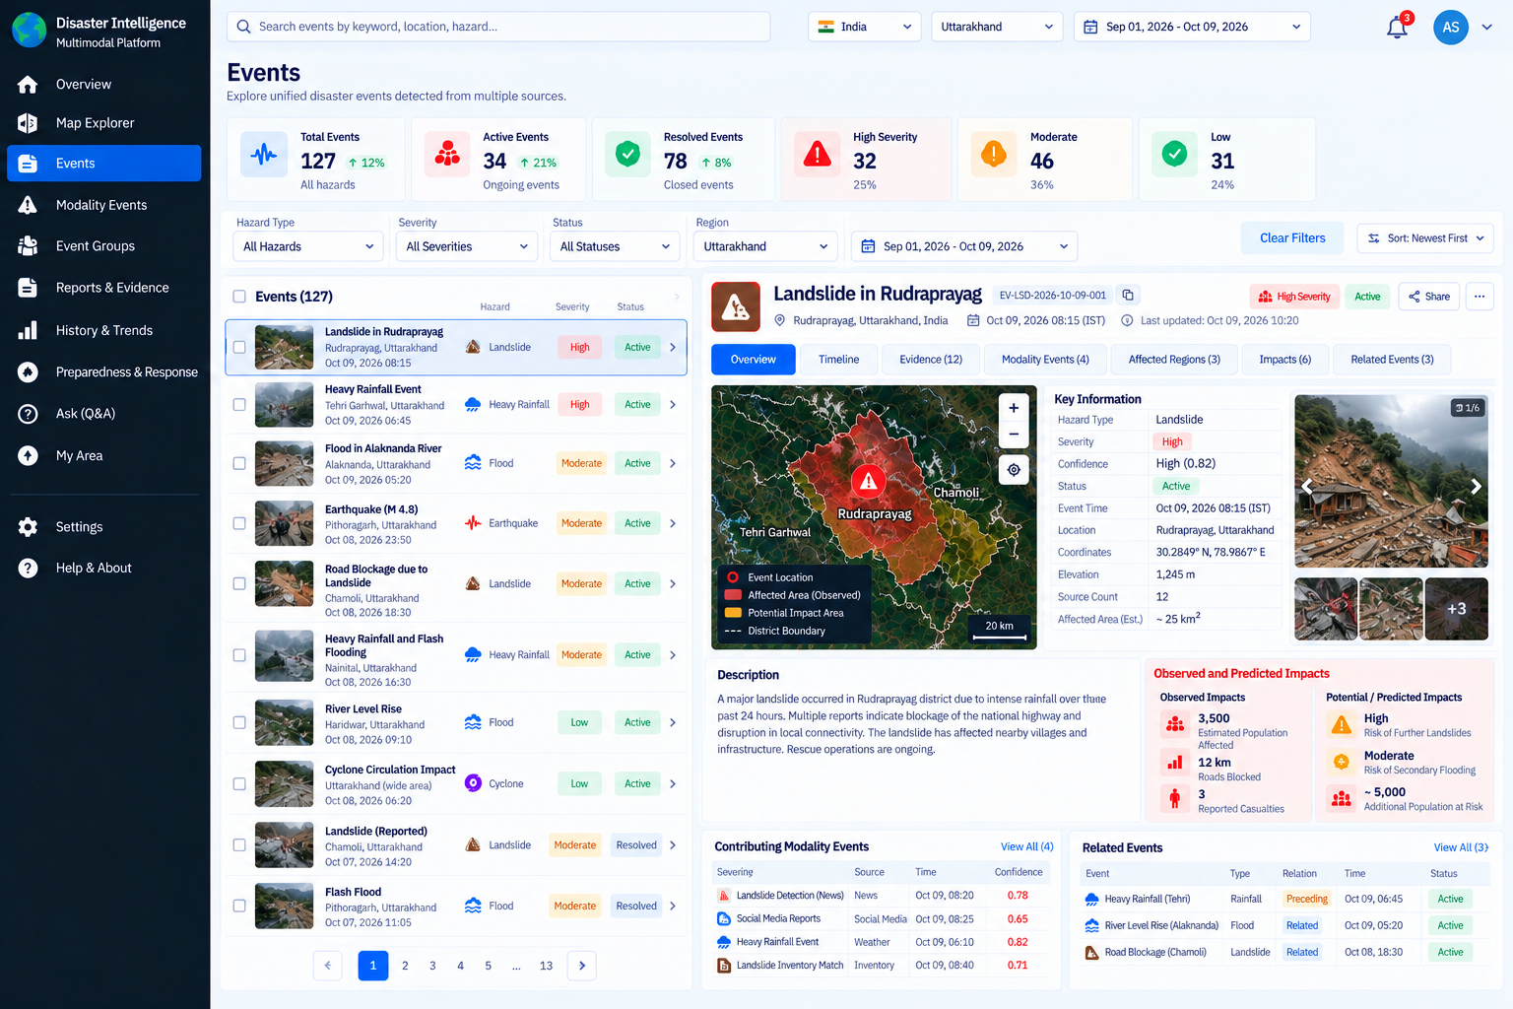

4. Modality Events
- List of events detected within individual modalities, such as earthquake, weather, news, and social media
- Filters: modality, hazard, region, time range, and processing status
- Event details: detection source, event time, location, and available confidence
- Supporting observations and derived results
- Link to the corresponding unified event, if matched
- Clear distinction between detected events, reported incidents, AI inferences, and predictions
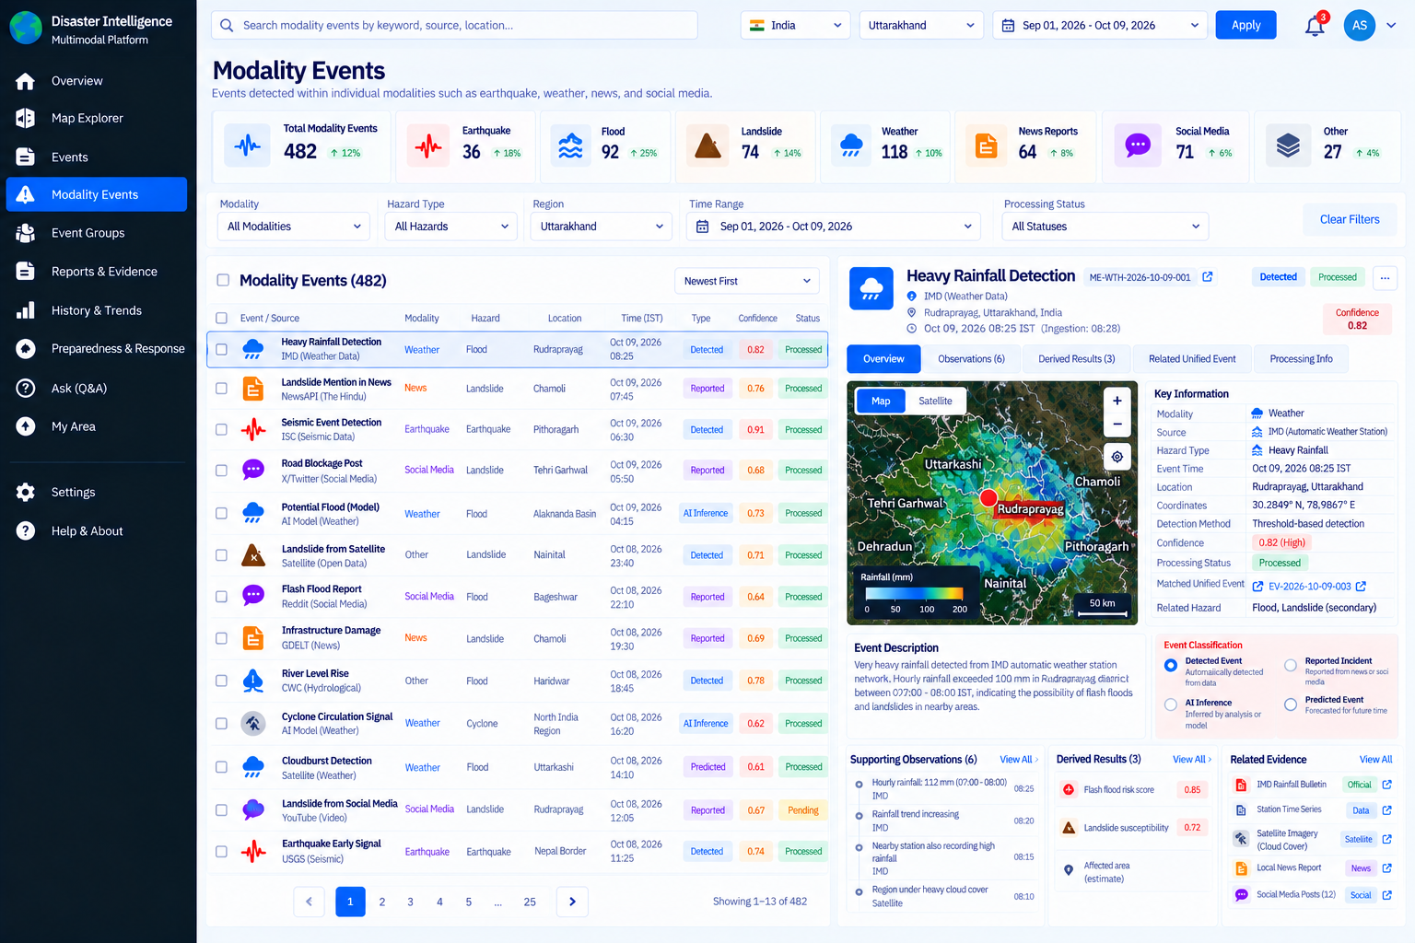

5. Event Groups (Episodes)
- Episode list and detail
- Relationship graph or timeline (e.g., rainfall → landslide → road blockage)
- Each link labeled: confirmed, reported, inferred, or possible
- Combined impact and affected area

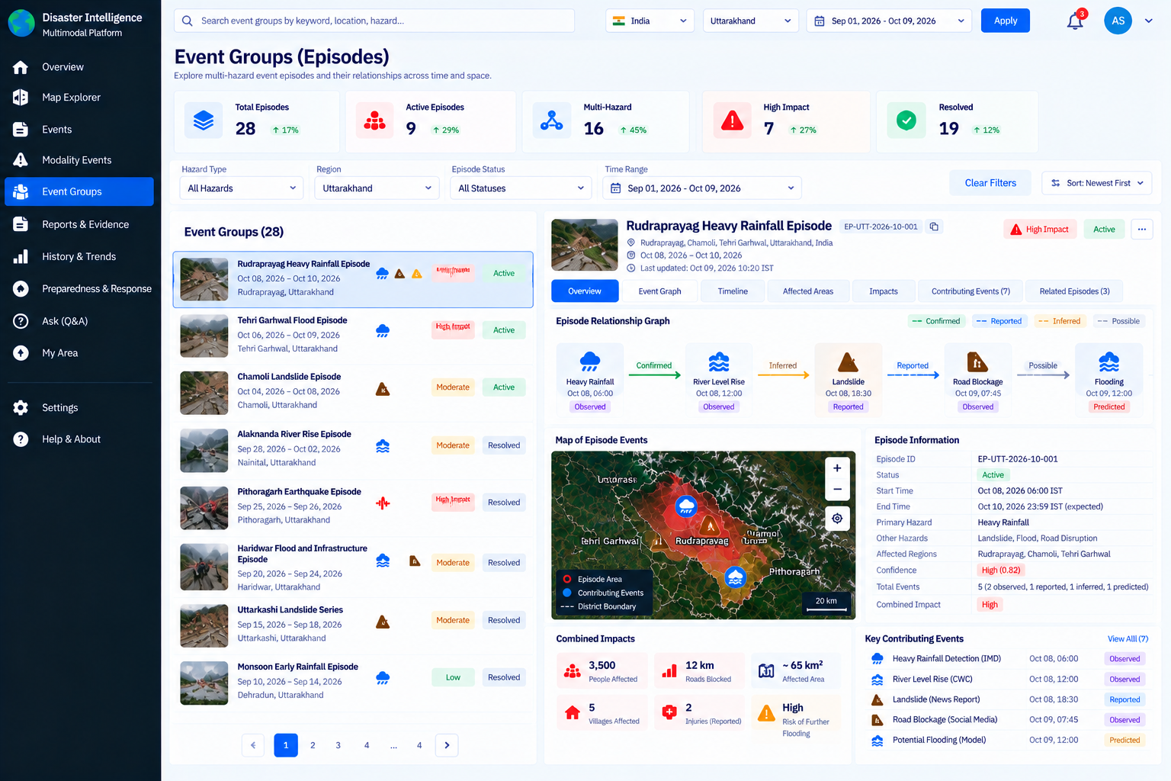

6. Reports and Evidence
- Source-backed feed: official reports, news, social/multimedia
- Filters: source type, verification status, hazard, region
- Link to the original source
- Language/translation toggle
- Clearly marked unverified items
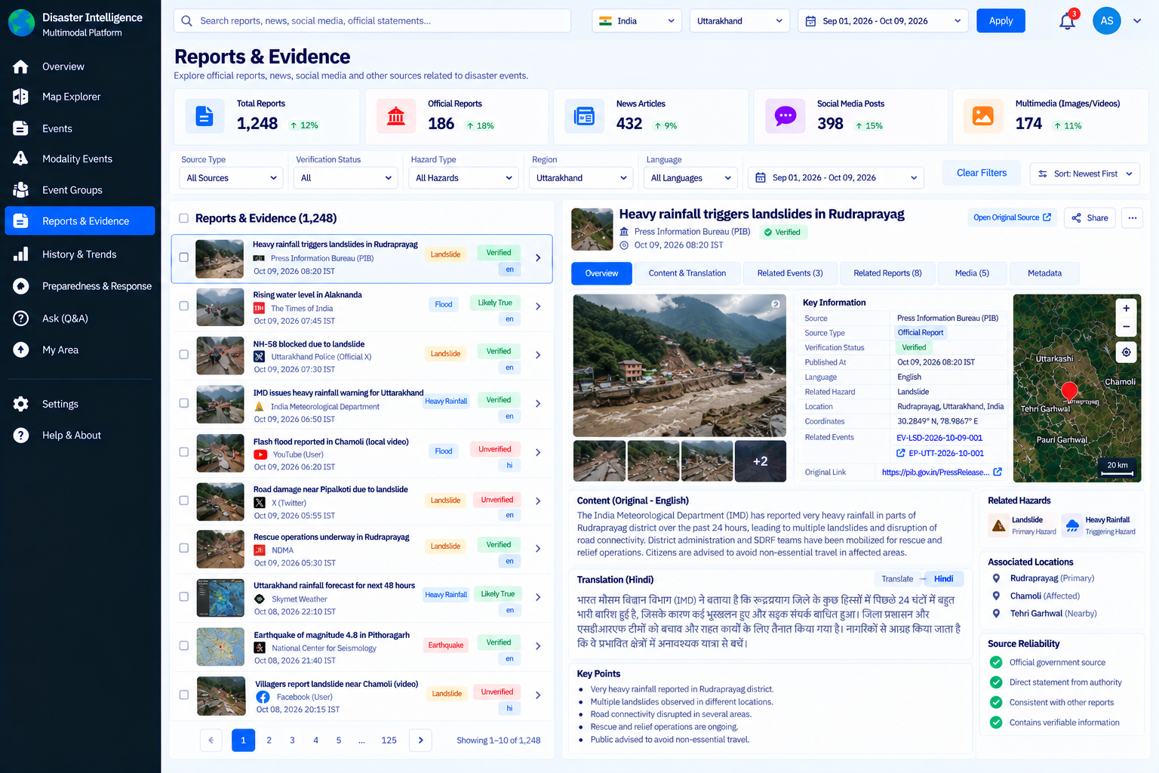

7. History and Trends
- Historical event search
- Seasonal and regional patterns
- Landslide inventory exploration
- Comparison with past events

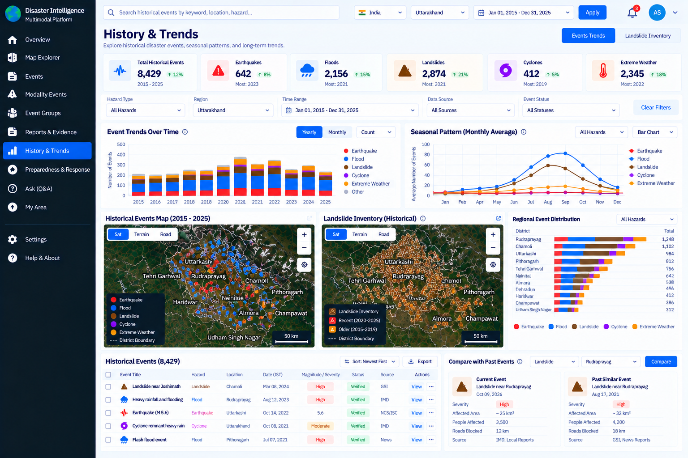

8. Preparedness and Response
- Verified emergency contacts, shelters, relief resources, safety guidance
- "Last verified" date on every item
- No routes or resources shown as safe or available unless confirmed

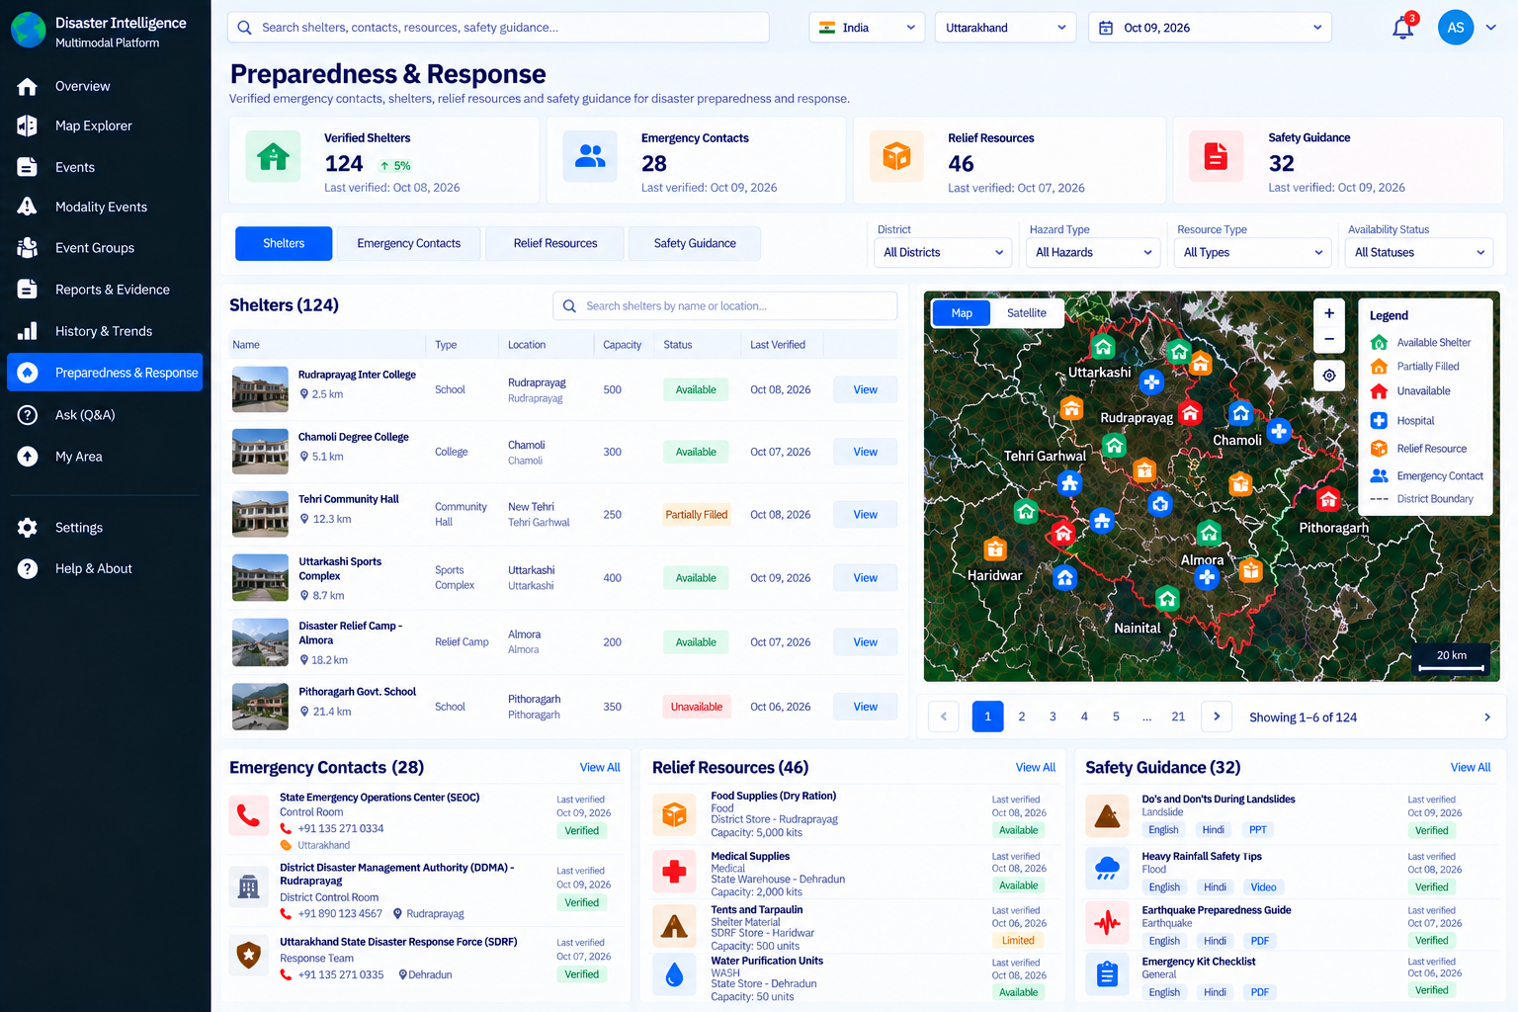

9. Ask (Evidence-Grounded Q&A)
- Natural-language search over events and reports
- Answers with citations to evidence
- Statements marked as fact, inference, or prediction

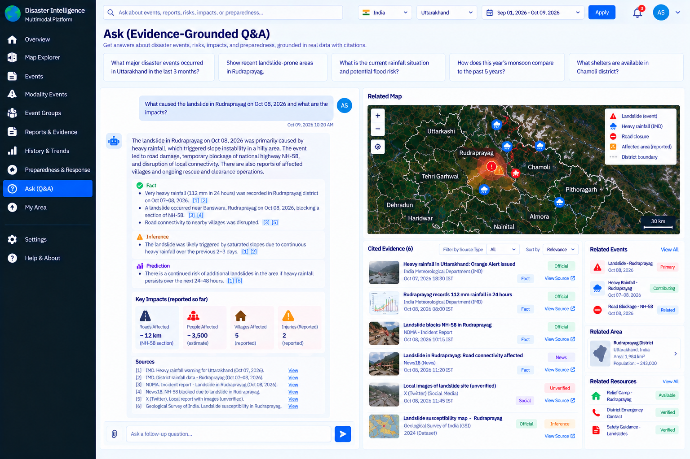

10. My Area / Settings
- Saved regions and hazards (watchlist)
- Notification preferences
- Units, language, and map defaults
